Meet UMCP Stakeholders
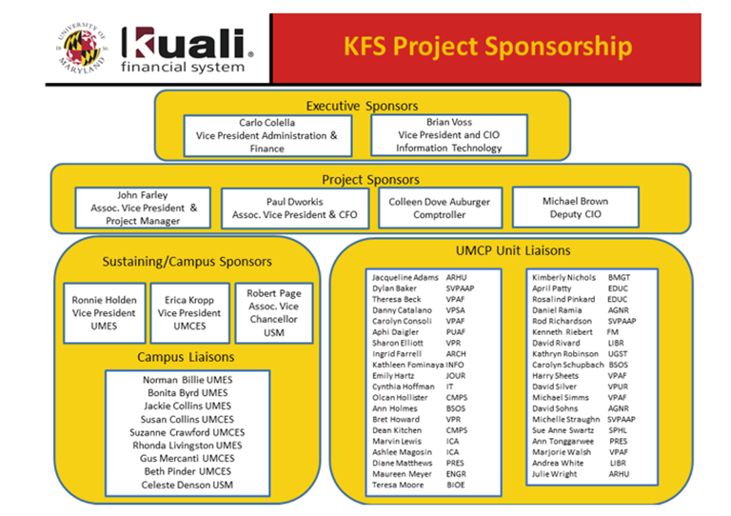
Additional Resources
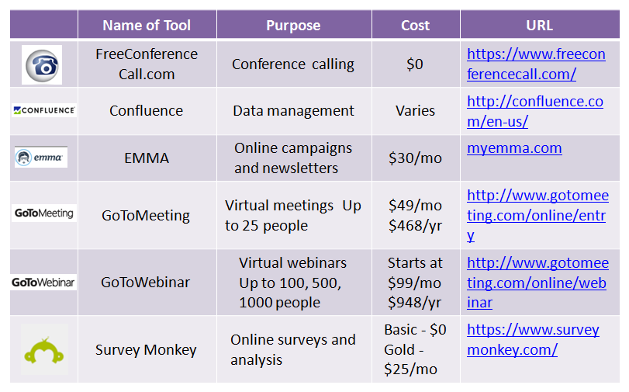

Want to talk more? Brenda Sprite | bsprite@navmp.com | 517.282.7042

